1. 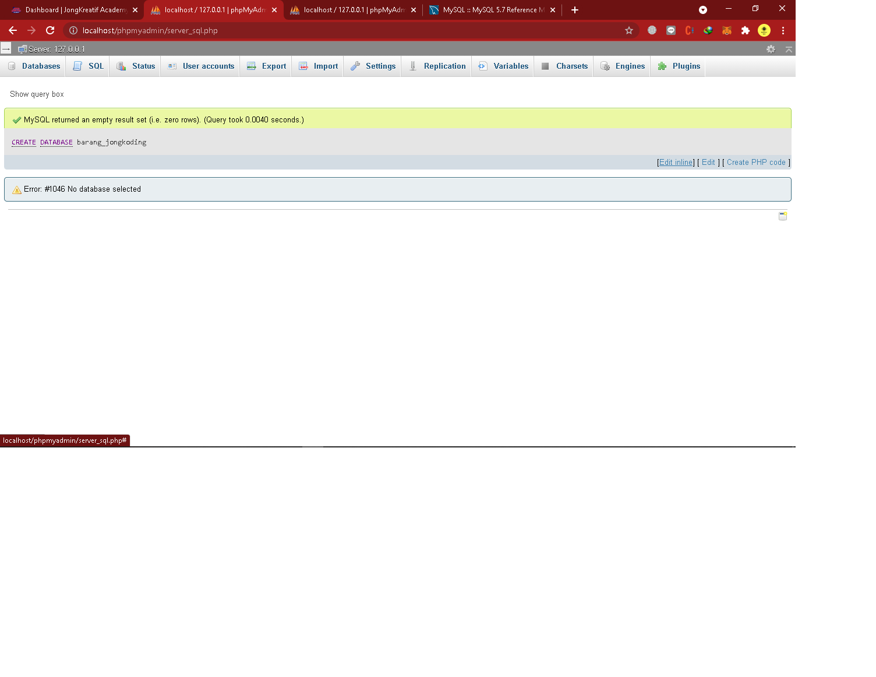
2. CREATE TABLE pelanggan (id_pelanggan int(10) NOT NULL, nama_pelanggan VARCHAR(50) NOT NULL, PRIMARY KEY(id_pelanggan)); 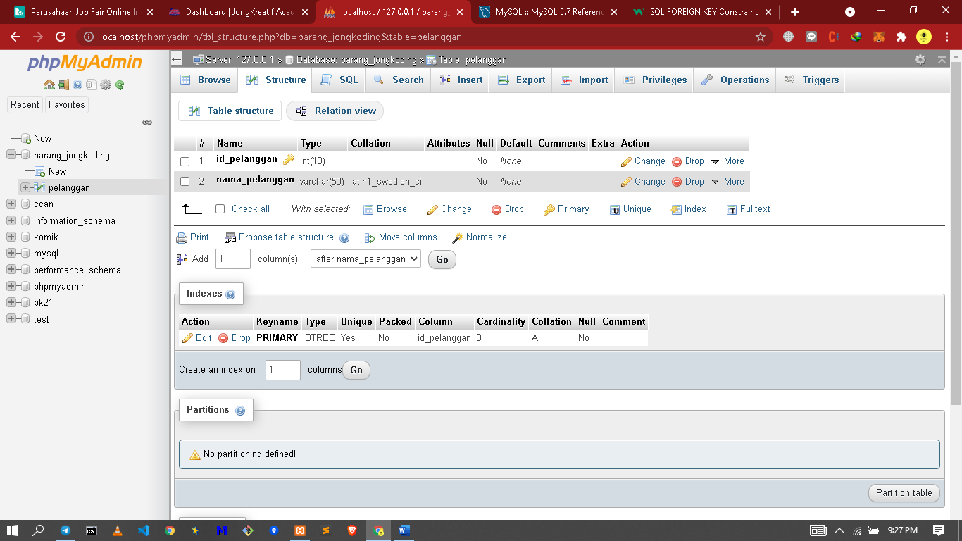
3. CREATE TABLE faktur (

id_faktur int(10) NOT NULL,

tanggal DATE NOT NULL,

id_pelanggan int(10) NOT NULL,

PRIMARY KEY(id_faktur),

FOREIGN KEY (id_pelanggan) REFERENCES pelanggan (id_pelanggan))

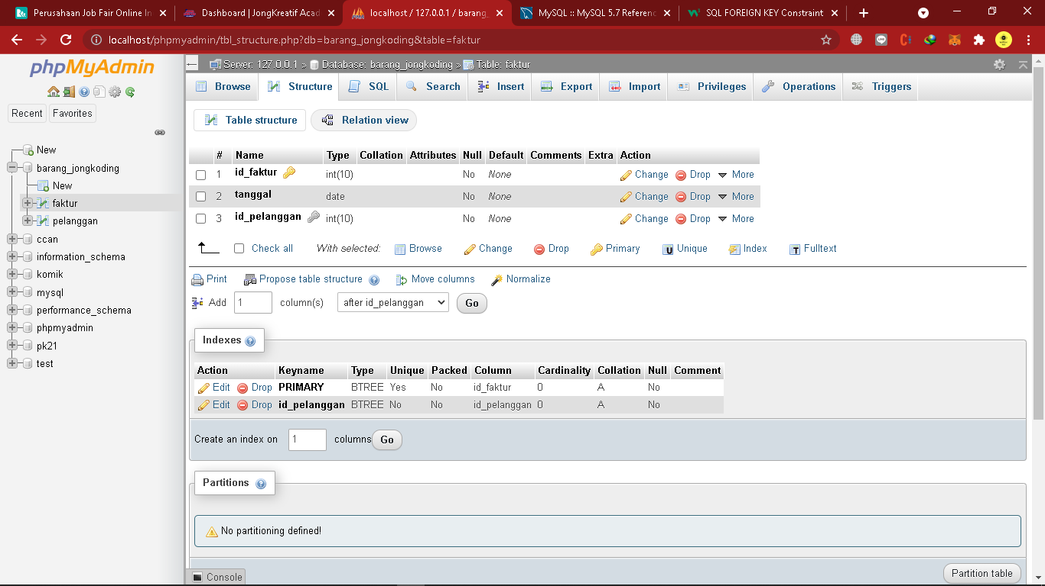

1. CREATE TABLE barang (id_barang int(10) NOT NULL, nama_barang VARCHAR(50) NOT NULL, harga int(50) NOT NULL, PRIMARY KEY(id_barang));  
   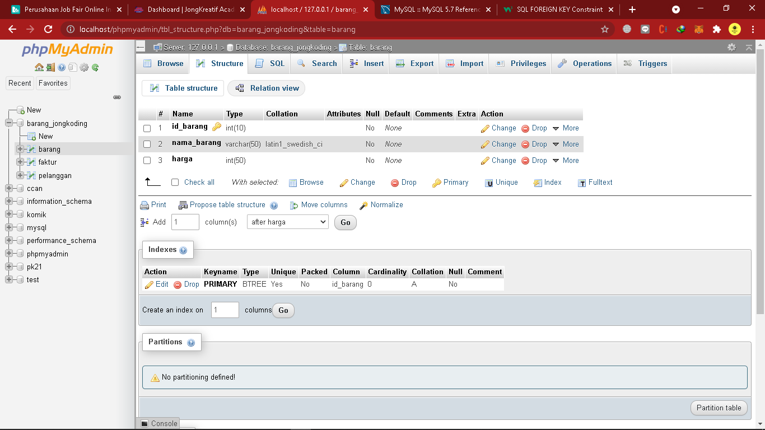
2. CREATE TABLE faktur_barang (

id_faktur int(10) NOT NULL,

id_barang int(10) NOT NULL,

FOREIGN KEY(id_faktur) REFERENCES faktur (id_faktur),

FOREIGN KEY (id_barang) REFERENCES barang (id_barang))

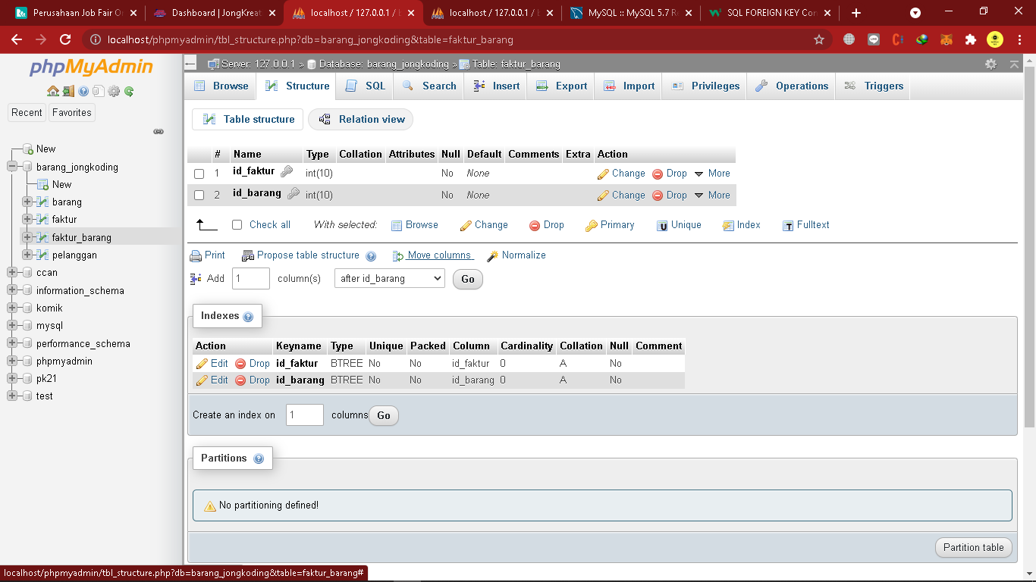

1. 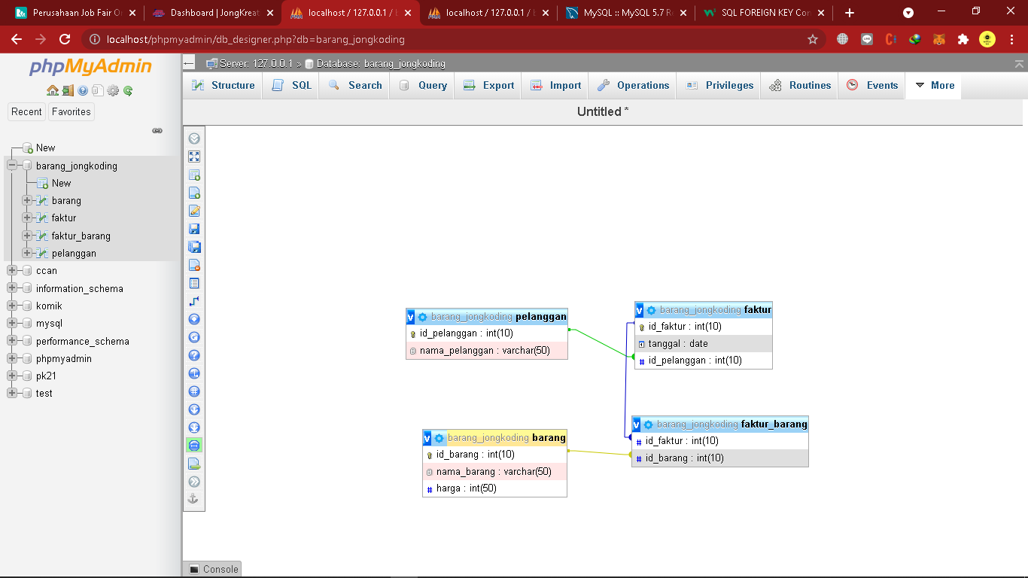
2. INSERT INTO `barang` (`id_barang`, `nama_barang`, `harga`) VALUES

('1', 'iphone 1', '1000000'),

('2', 'iphone 2', '2200000'),

('3', 'iphone 3', '3300000'),

('4', 'iphone 4', '4400000'),

('5', 'iphone 5', '5500000');  
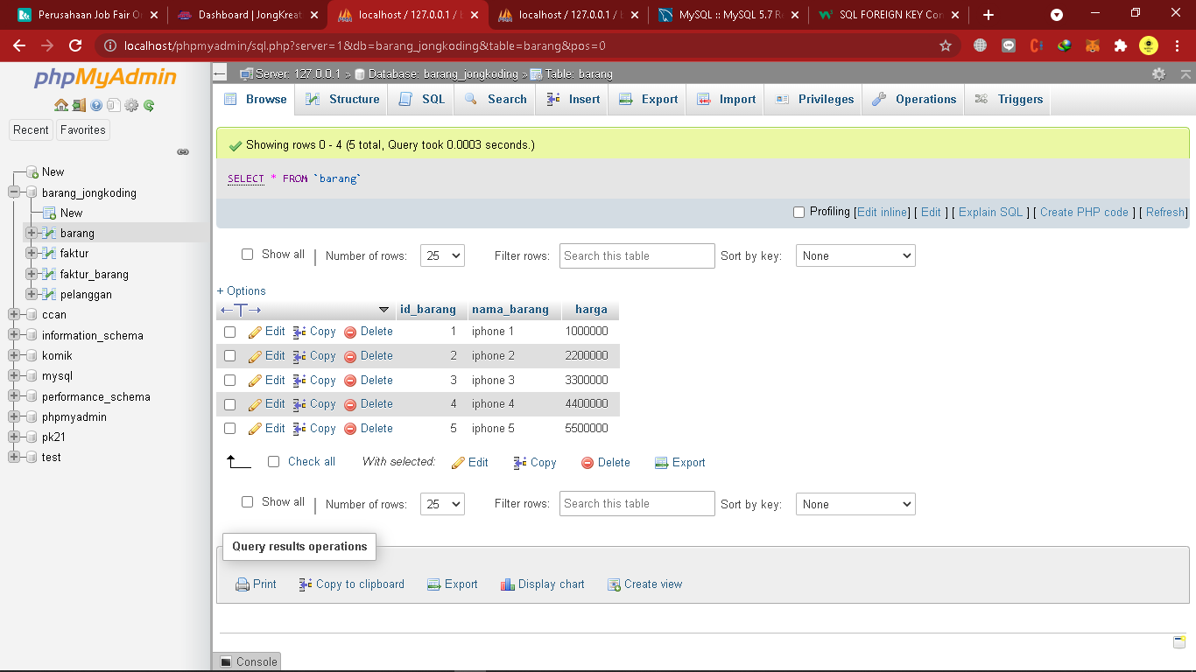

1. INSERT INTO `pelanggan` (`id_pelanggan`, `nama_pelanggan`) VALUES

('1', 'Firman Anshari Adjie'),

('2', 'Rizki Ananda'),

('3', 'Baharudin'),

('4', 'Nasarudin');

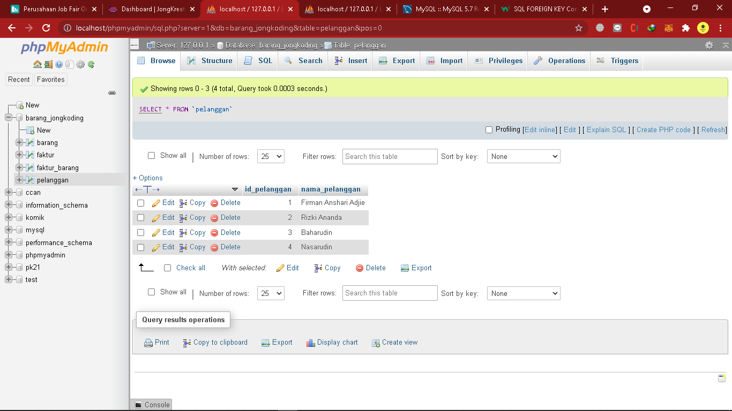

1. INSERT INTO `faktur` (`id_faktur`, `tanggal`, `id_pelanggan`) VALUES

('1', '2021-03-04', '1'),

('2', '2021-03-06', '2'),

('3', '2021-04-10', '3'),

('4', '2021-04-10', '1'),

('5', '2021-04-11', '4')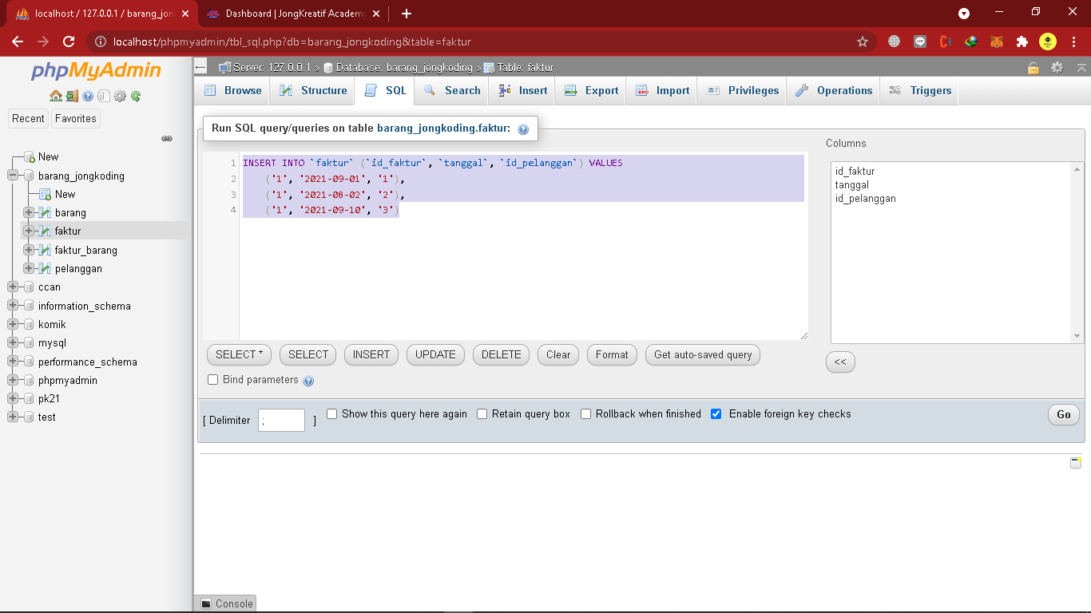

1. INSERT INTO `faktur_barang` (`id_faktur`, `id_barang`) VALUES

('1', '5'),

('1', '5'),

('2', '1'),

('3', '5'),

('4', '1'),

('5', '5')

